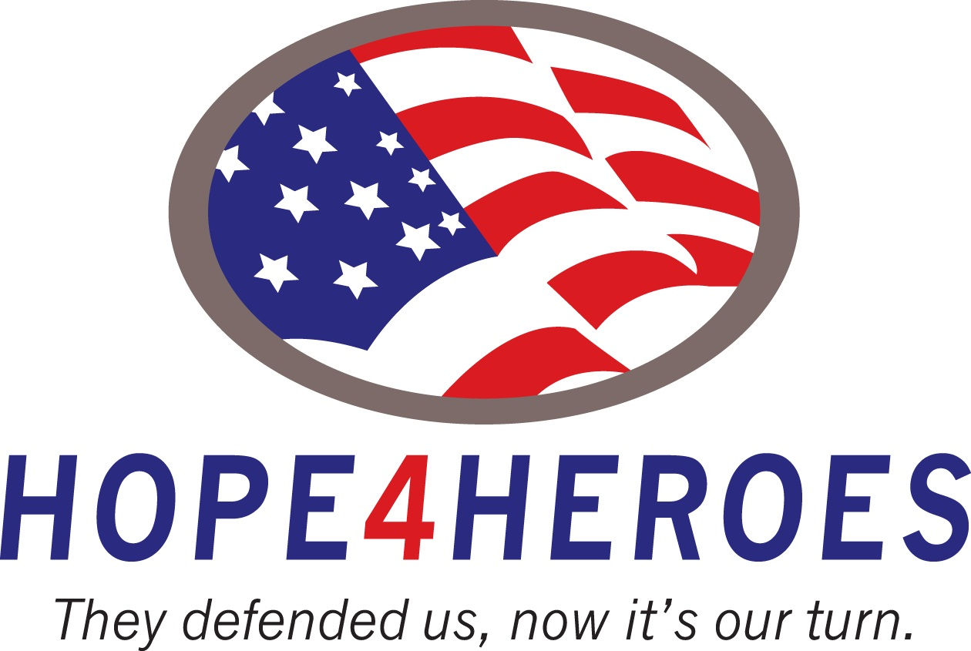

Walk4Heroes Presented by Yuengling
TO BENEFIT HOPE4HEROES
2-Mile self-paced walk supporting our military
Walk or run this self-paced fun event honoring and supporting our military past and present
SATURDAY, OCT 26th, 2013 - 9:00 AM
At large field- just east of the School Board Building
At 2700 Judge Fran Jamieson Way, Melbourne, Fl 32940
Registration at 8 am at Viera’s Fall Festival & Oktoberfest - under the Large Tent

Visit www.salutemilitary.com for more information
AMENITIES:
- Awesome Official Event T-Shirts
- Post Race contests and drawings
- Fun Filled Race Packets
- Great day of fun at Viera’s Fall Fest
$500 prize drawing after the race for runners
To register online
TIMETABLE:
Sat, Oct 26th: Register in Viera’s Fall Festival Large Tent
8:00 am Packet Pickup & Registration starts
9:00 am Walk Starts
11:00 am $500 prize drawing at Fall Fest
Sat/Sun: Oct 26- 27 Viera’s Fall Fest
Fest opens at 10:00 each day with live music, games, costume contest, vendors and more. Visit www.spacecoastdaily.com for the full schedule all weekend.

Sponsors welcome: To have your logo on shirts or a booth at Fall Fest contact golf@hope4Heroes.org or 321.604.9907
Great post walk raffle for all registered walkers and friends or guests. A $500 prize package that will be given away at under the main tent of Fall Fest. Don’t miss the fun with vendors, food, beer, prizes gifts and more all weekend long!
The Hope4heroes Walk4Heroes OFFICIALENTRY FORM
Send completed entry form with fee to and make check payable to:
Hope4Heroes Walk4 Heroes241 Provincial Dr., Indialantic, FL 32903
Name_______________________________________________
Address _____________________________________________
City ______________________ State _______ Zip __________
Phone (daytime) __________________ Email address _____________________________
Sex: ⁮ Male ⁮ Female Date of Birth _____/_____/_____ Age on Race Day _____

Please check shirt size: Sizes: Men’s: ⁮S ⁮M ⁮L ⁮XL ⁮XXL Women’s: ⁮S ⁮M ⁮L ⁮XL

Race Registration: ⁮ Oct 26th

INCOMPLETE OR UNSIGNED ENTRY FORMS WILL NOT BE ACCEPTED
In consideration of my entry being accepted, I intend to be legally bound, and hereby for myself, my heirs, and executors, waive all rights and claims for damages which may hereafter accrue to me against the sponsors, officials, volunteers, and supporters of this race and any representatives, successors, or assigns for any and all damages or injuries which may be sustained and suffered by me in consideration of my association with an entry or participation in the Warrior 5K Series event. If I should suffer injury or illness, I authorize the officials of the race to use their discretion to have me transported to a medical facility, and I take full financial and legal responsibility for this action. I attest and verify that I am physically fit and have my physician’s permission to participate in this race. I hereby grant full permission to any and all of the foregoing to use any photographs, videotapes, or any other record of this event for any purpose of the event whatsoever. I have read the above release and understand that it presents a risk of physical injury, knowing this I am entering this event at my own risk.
________________________________ ____________________________________________ __________
SIGNATURE SIGNATURE OF PARENT FOR THOSE UNDER 18 DATE

_______________________________________ ___________________
Signature (parent or guardian if under 18 Date

FEES: Reg Race Day
Walk4Heroes: $30.00 $35.00
Military ID: $22.00 $25.00
Raffle only: $10.00 Free for walkers
SORRY, NO REFUNDS / RACE HELD RAIN OR SHINE

